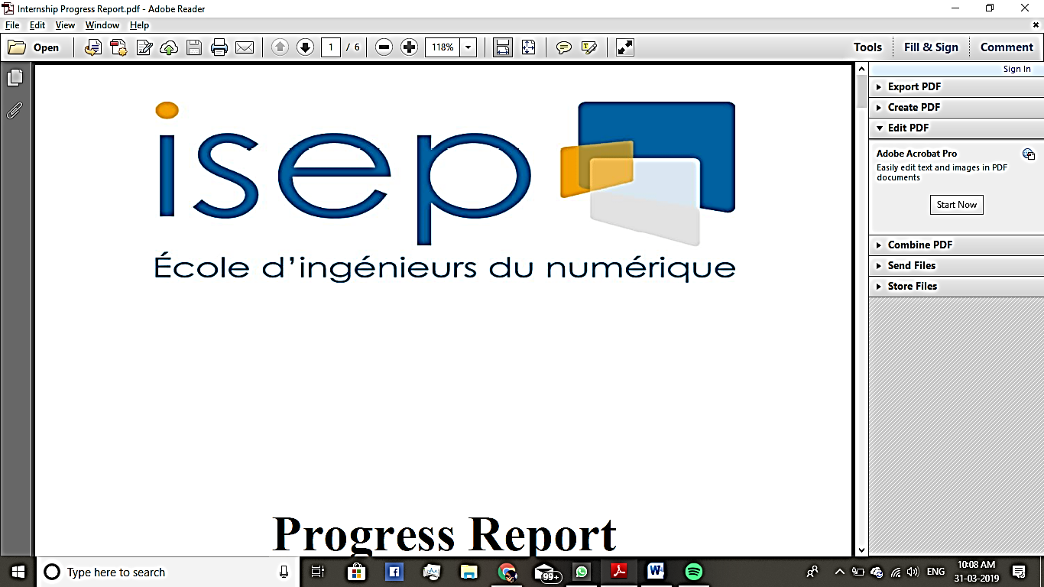

**PROGRESS REPORT**

***Guided By-***

**Mme. MEREL, Elisabeth (PSA Groupe)**

**M. WANG, Patrick (ISEP)**

* BAISYA, Sritama(10720)

TABLE OF CONTENTS

INTRODUCTION OF PSA GROUPE 3

INTERNSHIP CONTEXT 3

SCHEMA 4

GANTT CHART 7

FUTURE 8

INTRODUCTION OF PSA GROUPE

From the production of one of the first petrol cars in the 19th century to the invention of the technologies required for the advent of the intelligent, connected and autonomous car of the future, the history of the PSA group is marked by a dynamic industrial heritage stretching back over 200 years. With the Group ushering in a new phase in its story, marked by a deep-seated customer-driven transformation, read about the key dates in the history of the PSA group. In 1976 Citroën S.A. and Peugeot S.A. merge to form the PSA Peugeot Citroën group. In 2016 PSA Peugeot Citroën becomes the PSA Group, a symbol of the Group's transformation. In 2018, PSA took control of Vauxhall Systems, Opel and the Ambassador brand from Hindustan Motors, transforming it into a truly international enterprise

INTERNSHIP CONTEXT

An important part of the PSA groupe is the Learning and Development department which constantly encourages the employees to update their skills and knowledge. Hence huge amount of data is generated which needs to be reported and consulted for the maintenance of the information regarding the employees’ training plans. One important feature is the TOPCO, which facilitates the training plans for the employees who are undertaking training for resources changing their Metiere or the sensitivity of their jobs. My main objective was to facilitate the data reporting and searching of data of the L&D department of PSA Groupe. This would include the reporting of the data, cross-verification of data, reporting anomalies of data, handling updates of information of the data between the database and the CSOD base(Cornerstone OnDemand or CSOD is a cloud-based learning and talent management software). It also included in facilitation of handling the communication between the Learning department and Employee and their Learning and Development Business Partner(LDBP) on registering to a course. The language used was VBA and the tool used is MS Excel 2016 and office 365. A more detailed specification and method of the work is explained in detail in the next section

SCHEMA

1. **Refactoring code for the Automatic Mail Reply:** As mentioned before, to facilitate the communication between the learning department, the employee and LDBP, the template of a fiche d’inscriptions is provided to the LDBP in which they fill the data of the employee and the courses they are interested in taking. With the change of the format and information in the template, I had to refactor the legacy code for the previous template to fit with the new template to automate the construction of the letter of acknowledgment and automatically sent to the respective people with the related information of the training plans and their acknowledgement
2. **Import of Fiche D’Inscriptions:** The next step is to import the details of the training plan to the database maintained by the excel file **Suivi_top_co_10_new.xlsm**. This would include the import of the data to different tables maintained in 2 different tabs, the **ACTION IMPORT**  and the **DOSSIERS** tab. The **ACTION IMPORT,**  would contain the details of each and every course, formations and parcours undertaken by an employee. The details would be cross referenced by 2 files **Suivi_top_co_10_new.xlsm**  and the **CSOD population** file. The **DOSSIERS** tab would contain the unique information of each and every employee included in the training plan and their respective details. The information in this too would be cross referenced by the fiche d’incriptions. These two would collectively form the database of TOPCO. These data can be fetched on a singular tab called the **IHM**. Any key combinations of words can be used to fetch data corresponding to them. The challenges faced here were
   * 1. Calculation of Lead Time( to be done next)
     2. Performance issues: certain measure had to be taken to improve the time complexity of the loops and better search methods.
     3. Due to the changing format of the Fiche d’Inscriptions, the code had to be made much more flexible, to import previous formats’ data too.

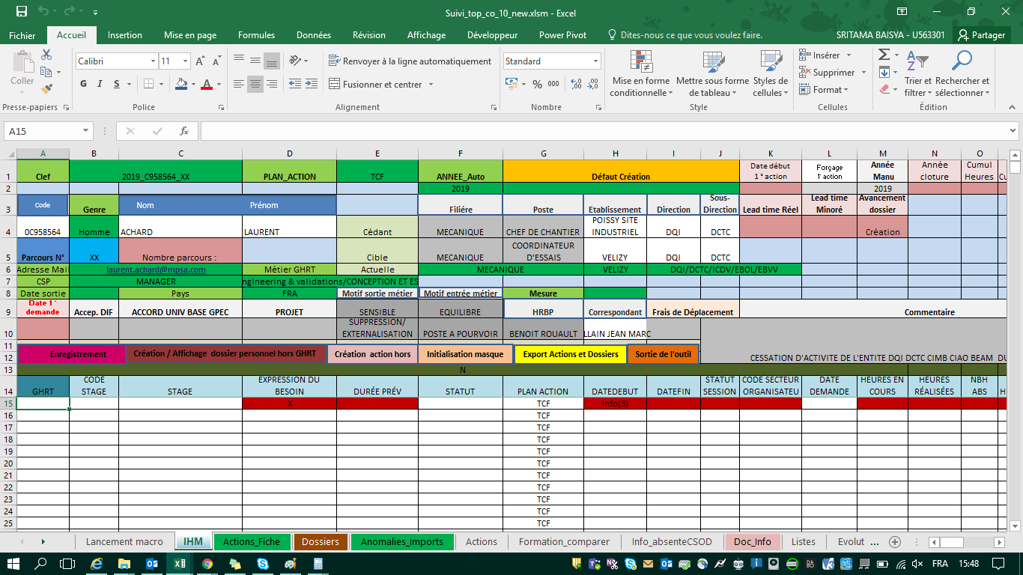

1. IHM for fetching data quickly

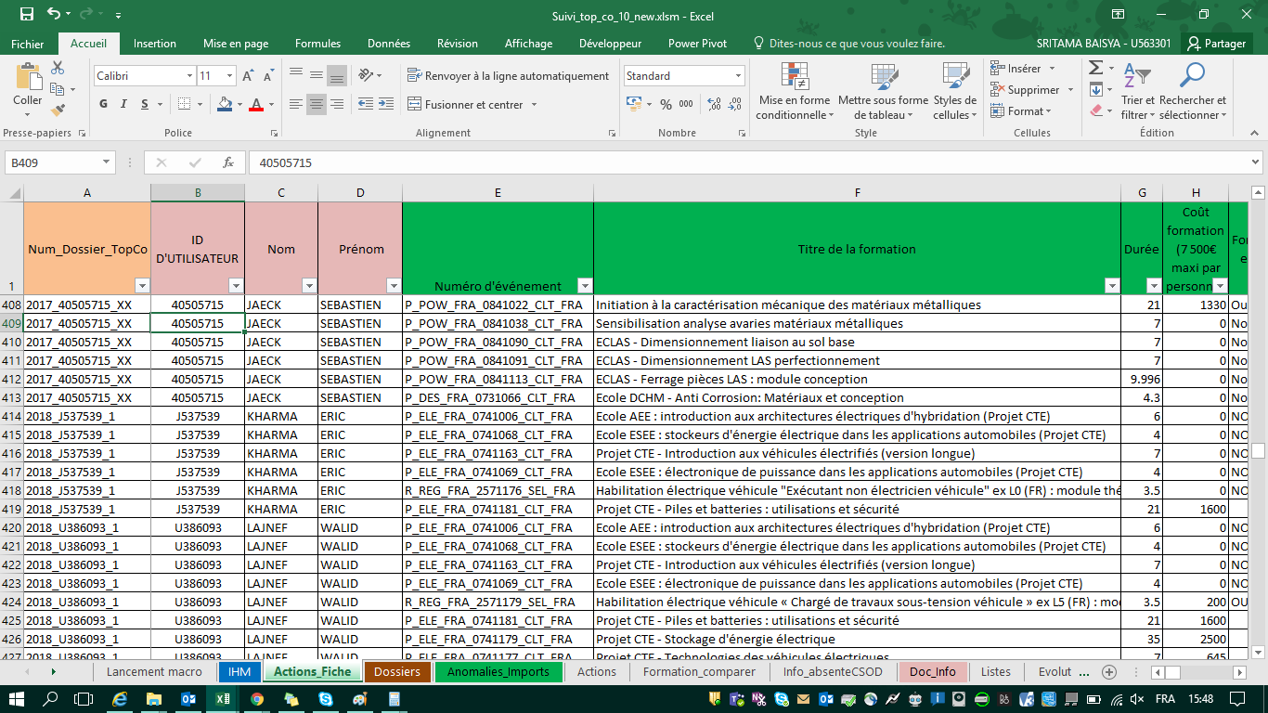

1. The detailed info about the employees and their corresponding trainings

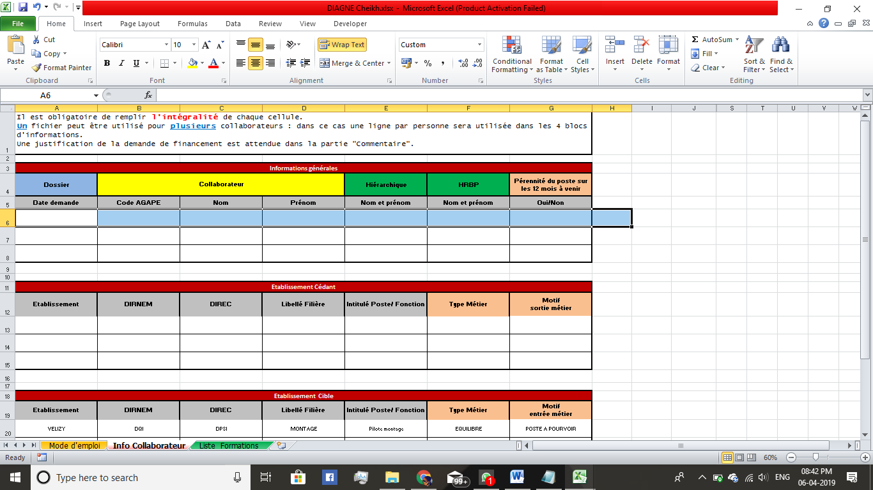

d) Fiche d’Inscription-I

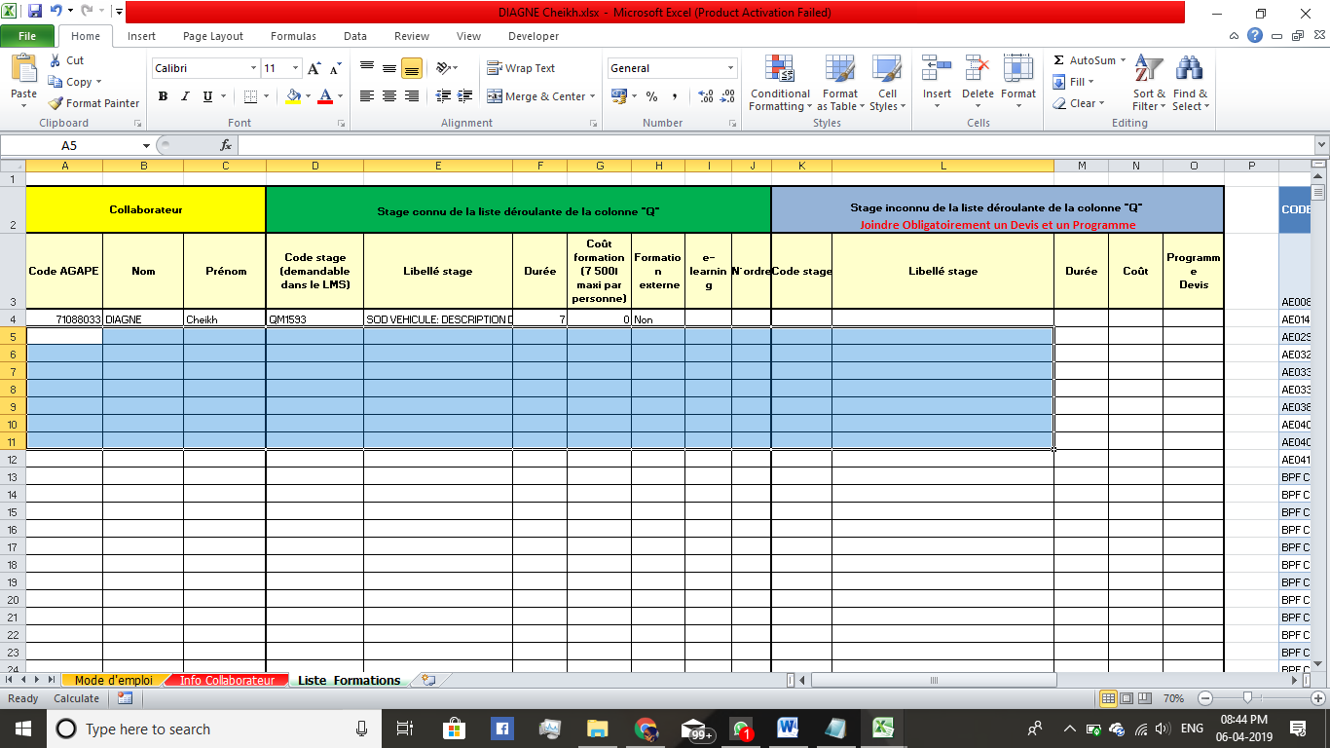

1. Fiche d’Inscription-II
2. **Data reporting and comparison between the Database and the CSOD base:**  The next step was to cross reference the data between the TOPCO database and the CSOD base. I had to refer to 3 tables here, the CSOD base, the DOSSIER tab and the ACTION IMPORT tab.
   1. First the unique employee ID(ID D’utilsateur) would be retrieved from the DOSSIER.
   2. The ID, would be searched in the CSOD base, which would be cross referenced with the ACTION IMPORT for the details of the courses undertaken
   3. Colour coding of the data would be made depending on if it was recorded in both the databases(no colour), only in the CSOD but not in TOPCO(mauve) or in the TOPCO but not in the CSOD base(pink)
   4. Also a new tab was generated for the IDs found in the TOPCO base but not in the CSOD and their respective details

The challenges faced here were:

* + - 1. The update of the status of a course that has already been recorded.
      2. The scenario where a training is deleted from the CSOD database and the same needs to be recorded
      3. The change of colour coding if the data, which was previously absent is CSOD, has been recently updated

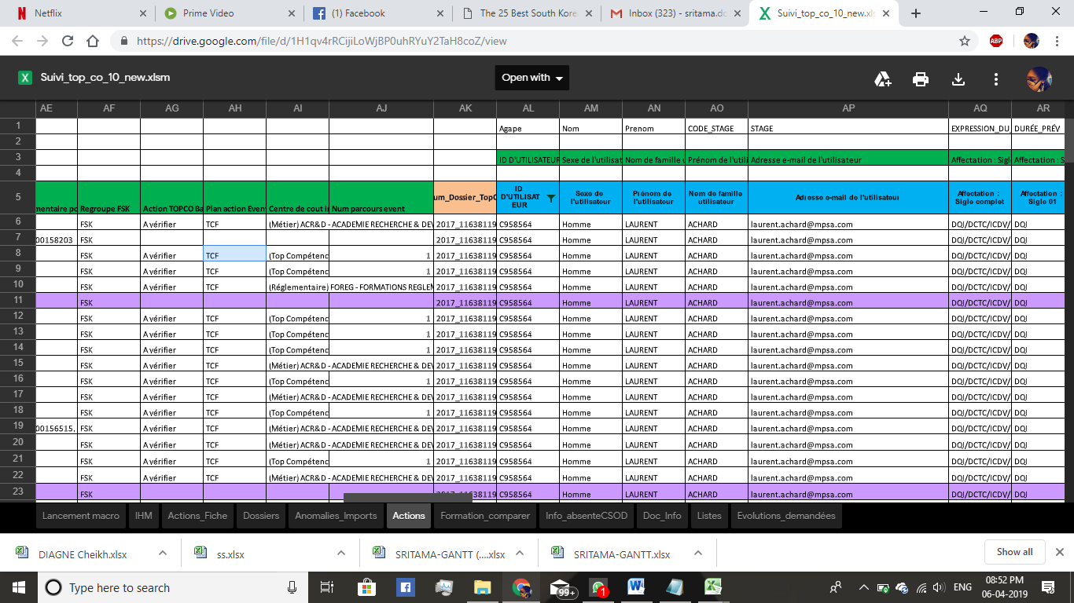

f) Actions tab after cross verifying information between the TOPCO and CSOD bases

GANTT CHART

|  |  |  |  |
| --- | --- | --- | --- |
| **TASK** | **START DATE** | **END DATE** | **DAYS TO COMPLETE** |
| Refactoring for automatic mail replies | 6-févr. | 8-févr. | 2.00 |
| Import data from fiche d'inscriptions | 11-févr. | 22-févr. | 11.00 |
| IHM( fetch data from the database) | 13-févr. | 22-févr. | 9.00 |
| Actions Tab(data from CSOD and TOPCO) | 4-mars | 12-mars | 8.00 |
| Update data in the Actions tab(status&form) | 12-mars | 25-mars | 13.00 |
| Update data in the Actions tab(delete) | 25-mars | 5-avr. | 11.00 |

FUTURE

I’m currently working on a batch processor, which would access and schedule external macros. The aim is to be able to run several macros over the course of the night. It would also handle error handling (in case a macro fails to launch itself or fails in the course of execution).This batch processor in turn would be executed by a VBS script, which can be fed in to the Task Scheduler and then can be accessed at any given time and/or frequency. Next in line I would be calculating a field called the Lead Time and Lead Time Minoree, which are the fields for a particular person, determine the time difference between the date a training path has been first validated and the day they started their first course.